

**SmartLibrarian**

ISS IPA TEAM XX PROJECT REPORT

ONN WEI CHENG A0092201X

YANG JIESHEN A0003901Y

NIRAV JANAK PARIKH A0213573J

**TABLE OF CONTENTS**

1. Problem Statement 2

1.1. business case 2

1.2. Our ProposaL 3

2. System Overview 4

2.1. agent system: Conversational UI 4

2.2. RPA: NLB Availability checker 4

2.3. RPA: amazon recommendation system 4

2.4. local AI: intelligent title matcher & abstract Summariser 4

2.5. RPA: Email agent 4

3. System IMPLEMENTATION 5

3.1. agent system: Conversational UI 5

3.2. RPA: NLB Availability checker 5

3.3. RPA: amazon recommendation system 5

3.4. local AI: intelligent title matcher & abstract Summariser 5

3.5. RPA: Email agent 5

4. conclusion 6

4.1. SUMMary of achievements 6

4.2. Future ImprovementS 6

**APPENDICES**

APPENDIX I: PROJECT PROPOSAL

APPENDIX II: SYSTEMS MAPPED TO COURSE OBJECTIVES

APPENDIX II: SMARTLIBRARIAN INSTALLATION AND USER GUIDE

APPENDIX IV: SMARTLIBRARIAN SAMPLE USERCASES

1. Problem Statement

What should you read? For both the avid readers and uninitiated, the major retailers, such as Amazon and Kinokuniya, provide a constantly list of best sellers, while blogs and other websites share the must-reads with titles such as “The Top 30 books you must read in your lifetime”. The recommendations are aplenty but how to do readers discern between the different recommendations and how do they get hold of the book for free? This is what SmartLibrarian is here to solve.

* 1. business case

The impact of Covid 19 has turned many businesses online and people toward activities that can be done individually and at home. The online book service market, is not an expectation to this trend, with an annual compounded growth of 6.2% per annum with an expectation to reach 23.8 Billion in 2026.[1]

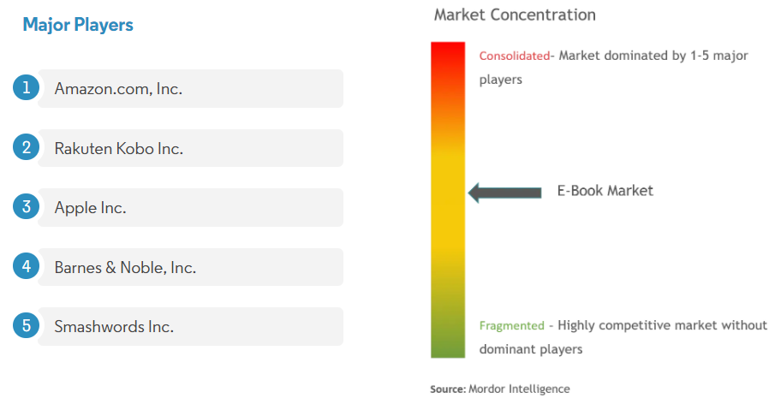

Figure : Market Concentration[2]

Major industry players in the fragmented ebook market that had a foothold in the ebook market also made moves to consolidate their position. For example, Amazon.com, offered the users a free trial of two months on their “Kindle Unlimited” service since June 2020 in an attempt to on board more users.

*Uniqueness of solution and revenue generation

* 1. Our ProposaL

Smart Librarian is an Intelligent Book Borrowing System that can check for the availability of the books with our National Library Board (NLB) so it can be borrowed for free and also recommend books based on your selections.

The goal of the project will be to deliver a Minimum Viable Product (MVP) of our Intelligent Book Borrowing System, SmartLibrarian with the following objectives:

**Activating The Application On The Go**

Integrated with Google Assistant, you can check the availability of a book using your smart phone, no matter where you are. Natural language voice and text support is also a provided to ensure a simple and natural workflow.

**Checking The Availability And Recommendation Of Books**

Boosting a huge selection of books and a great association recommendation system, our application taps on the Amazon system using a Robotic Proces Automation (RPA) to recommend books for the users. An RPA is also used to check the NLB website for the availability of books. As NLB and Amazon both uses their own proprietary search engine, a matching system is also developed to ensure that the results from both NLB and Amazon are the same.

**Notifying The Users On Availability And Recommendations**

An email will be sent to the user to inform the user on the availability of the books selected and the associated recommendations. Summarised abstracts of the book and the links to borrow the books in NLB will be included in the email to tease the content of the book and to ensure a seamless borrowing process respectively.

1. System Overview

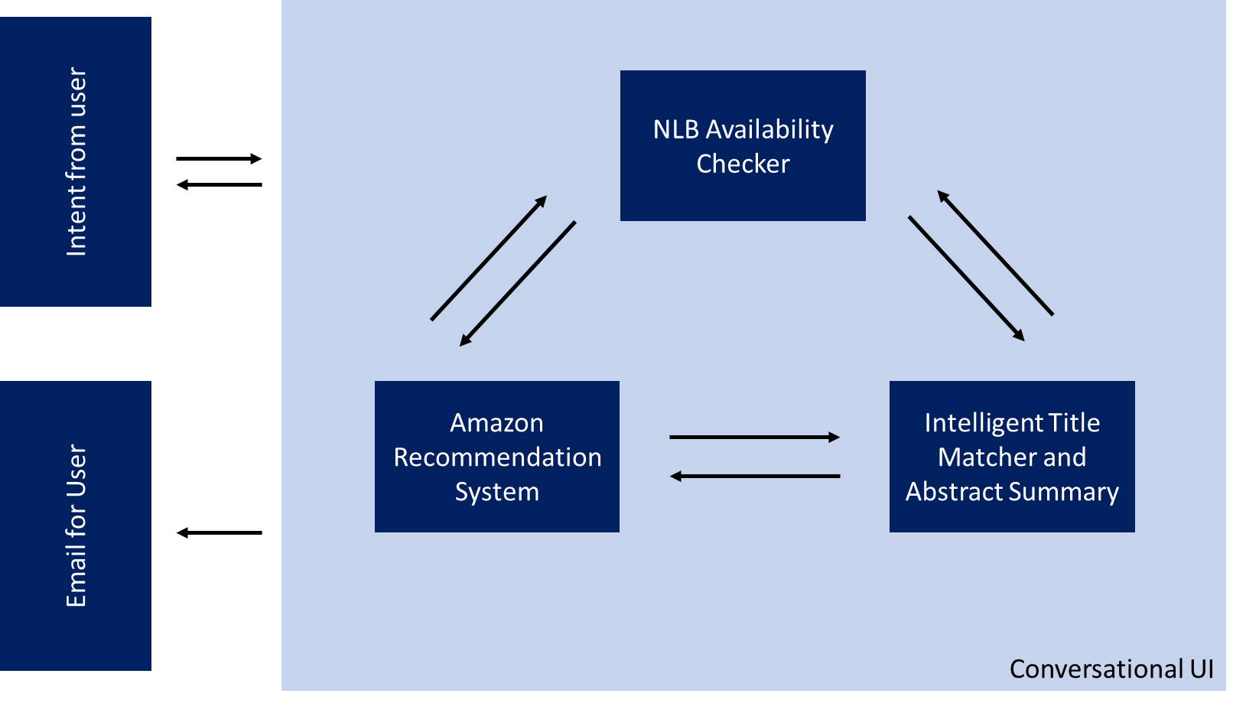

Figure : System Overview

An overview of the system in given in **Figure 2**. The following sub-sections summarise the major features of the application.

* 1. agent system: Conversational UI
  2. RPA: NLB Availability checker
  3. RPA: amazon recommendation system

* 1. local AI: intelligent title matcher & abstract Summariser
  2. RPA: Email agent

1. System IMPLEMENTATION
   1. agent system: Conversational UI
   2. RPA: NLB Availability checker
   3. RPA: amazon recommendation system
   4. local AI: intelligent title matcher & abstract Summariser
   5. RPA: Email agent
2. conclusion
   1. SUMMary of achievements
   2. Future ImprovementS

Despite a successful implementation for a minimum viable product, there are areas for future improvements.

**Appendix I: project proposal**

**appendix ii: SYSTEMS mapped to course objectives**

|  |  |  |
| --- | --- | --- |
| **System** | **Sub-System** | **Relevant Course Objectives** |
|  |  |  |

Task/RPA-bot OR Virtual Assistant OR other relevant robotic/intelligent process automation technologies

Local AI OR Cloud AI OR other relevant data-driven machine learning technologies

Single/Multi agent system OR other relevant agent based technologies, e.g. MyCroft AI; ACL

**Appendix Iii: SMARTLIBRARIAN installation and user GUIDE**

**Appendix Iv: SMARTLIBRARIAN sample usecases**

1. https://www.reportlinker.com/p05975423/Global-Online-Book-Services-Market-By-Category-By-Region-Industry-Analysis-and-Forecast.html?utm_source=GNW
2. https://www.mordorintelligence.com/industry-reports/e-book-market